**EXPERIMENT-12**

1.Create a sequence by name EMPID_SEQ starting with value 100 with an interval of 1.

2. Write a SQL command for finding the current and the next status of EMPID_SEQ

3.Change the Cache value of the sequence EMPID_SEQ to 20 and maxvalue to 1000.

4. Insert values in employees table using sequences for employee_id column

5. Drop sequence EMPID_SEQ

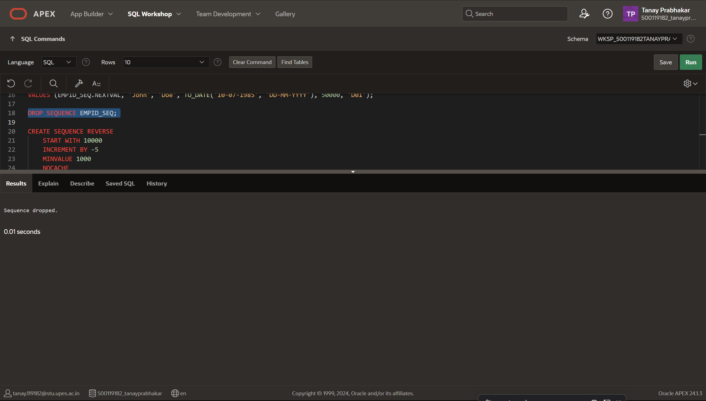

6. Create a sequence called REVERSE to generate numbers in the descending order from 10000 to 1000 with a decrement of 5.

**EXPERIMENT-13**

1.Write a PL/SQL code to accept the value of A, B & C display which is greater.

2. Using PL/SQL Statements create a simple loop that display message “Welcome to PL/SQL Programming” 20 times.

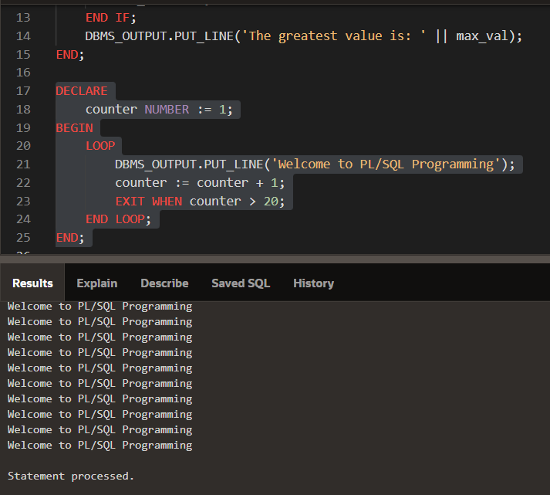

3. Write a PL/SQL code block to find the factorial of a number

4. Write a PL/SQL program to generate Fibonacci series

5. Write a PL/SQL code to fund the sum of first N numbers

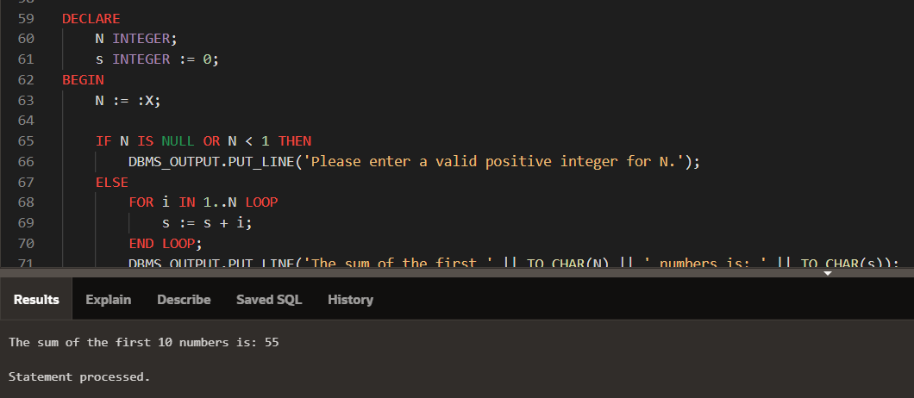

**EXPERIMENT-14**

Implement the above experiments of PL/SQL using functions and procedures.

1.

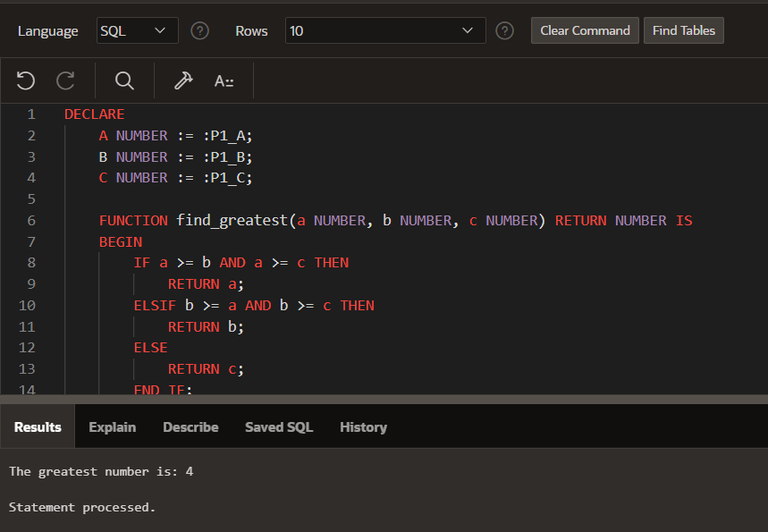

2.

3.

4.

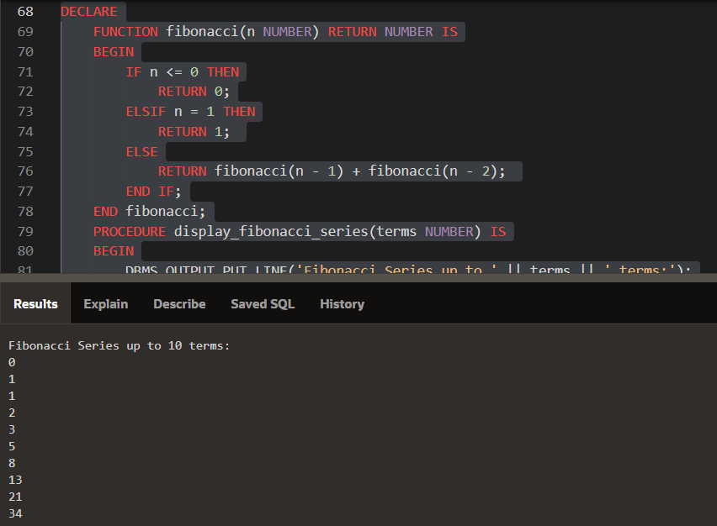

5.

**EXPERIMENT-15**

1.Using implicit cursor update the salary by an increase of 10% for all the records in EMPLOYEES table, and finally display how many records have been updated. If no records exist display the message “No Change”.

2.Using explicit cursor fetch the employee name, employee_id and salary of all the records from EMPLOYEES table.

3. Using explicit cursor Insert the records from EMPLOYEES table for the columns employee_id, Last_Name and salary for those records whose salary exceeds 2500 into a new table TEMP_EMP

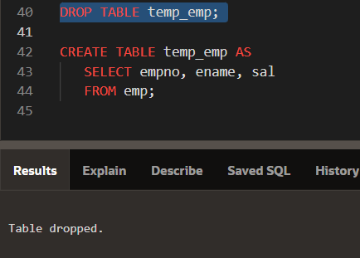

**EXPERIMENT-16**

1. Create a row level trigger for the customers table that would fire for INSERT or UPDATE or DELETE operations performed on the CUSTOMERS table. This trigger will display the salary difference between the old values and new values.

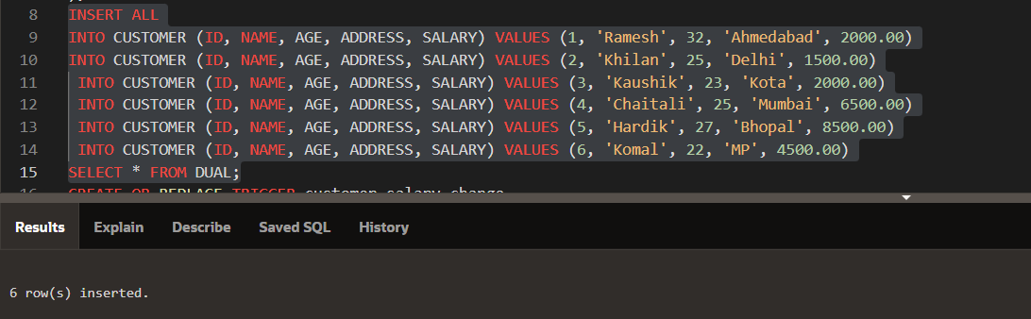

**EXPERIMENT-17**

CREATE TRIGGER SALARY_VIOLATION BEFORE INSERT OR UPDATE OF SALARY, SUPERVISOR_SSN ON EMPLOYEE of experiment 3

